**Winter 2018 Mid-Year Milestone Evaluations Reporting Window: *October 29, 2018 - January 11, 2019***

**Milestones:**Description of performance levels residents and fellows are expected to demonstrate for skills, knowledge, and behaviors in the six ACGME Core Competency domains.

**These evaluations are a mandatory part of program accreditation through the ACGME.**

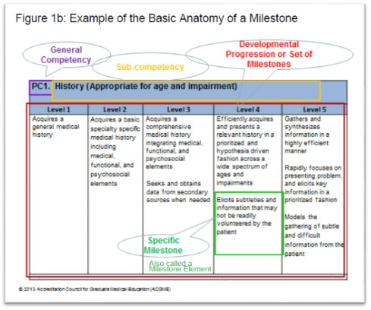

The Program Director or Coordinator can complete them, but they must be based on data provided by the **Clinical** **Competency Committee (CCC),**an ACGME required committee comprising three or more members of the active teaching faculty. An evaluation must be completed for *each*scheduled trainee within the program. If a trainee completes or leaves a program during the current academic year, an evaluation may still be required. Incomplete or un-submitted evaluations will NOT be accepted.

You can find further information on the Milestone Evaluations and how they are being used within the Next Accreditation System (NAS) on the ACGME website at the [Milestones Resources page](https://www.acgme.org/What-We-Do/Accreditation/Milestones/Resources)of the Milestones section of the website.

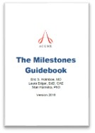Also on that site you will find the ***2018******Milestones National Report*.**The third edition of the report presents national Milestones data in aggregate form for the latest academic year (July 1, 2017-June 30, 2018) for 36 specialties and 99 subspecialties.

Program Directors and Coordinators will want to review the additional online resources and tools for more information, including the ***Milestones Guidebook***, Milestones FAQs, ***Milestones Guidebook for Residents and Fellows***, and the ***Clinical Competency Committee Guidebook***, all available on the Milestones section of the ACGME website.

For those interested, there is also an ***ACGME Milestones in GME: History, Educational Theory, Rationale, and Experience from the First Five Years***webinar presented by the AAMC with Eric Holmboe, MD, MACP, FRCP, ACGME Senior Vice President, Milestone Development and Evaluation at <https://www.aamc.org/initiatives/meded/492180/milestonesweebinar09072018.html> (recorded September 2018).

Laura